SESSION:-1
use("foodieApp")
switched to db foodieApp
db["restaurants"].find()
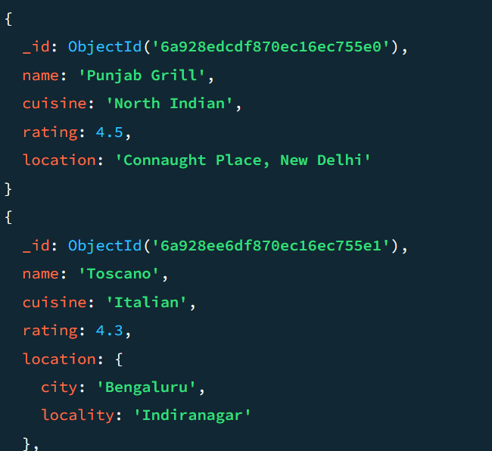
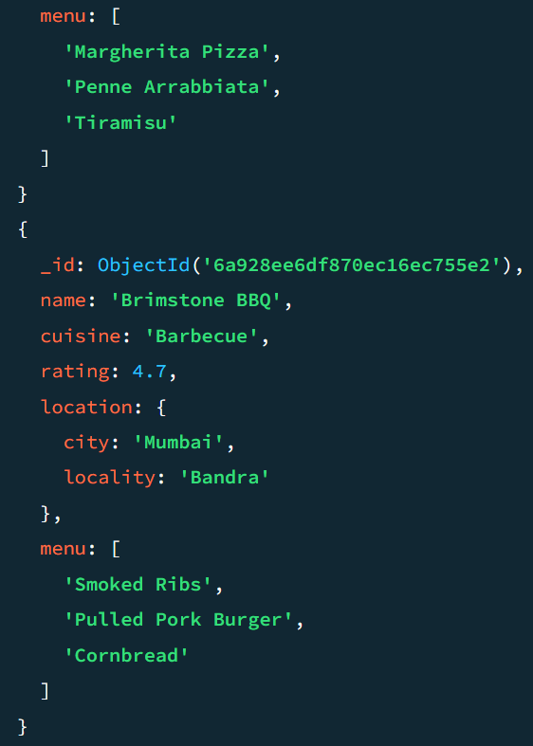

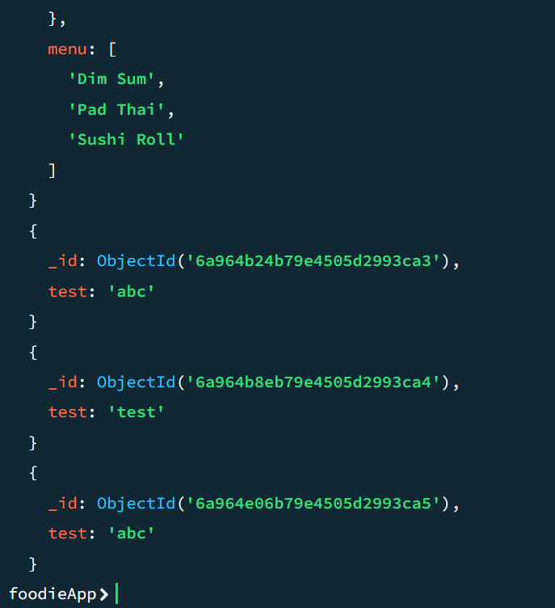
SESSION:-2
- use insta_clone_db
Output: switched to db insta_clone_db)
- db.createCollection("posts")
(Output: { ok: 1 })
db.stories.insertOne({
username: "johndoe",
image_url: "https://example.com",
timestamp: new Date()
})
4. db.stories.drop()
(Output: true)
5. show collections
(Output: posts)
6. db.dropDatabase()
(Output: { dropDatabase: "insta_clone_db", ok: 1 })
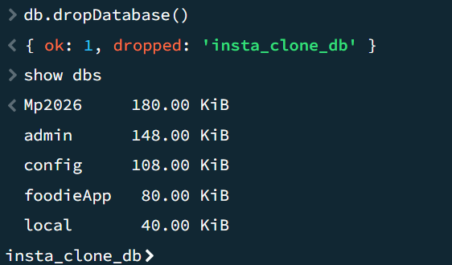
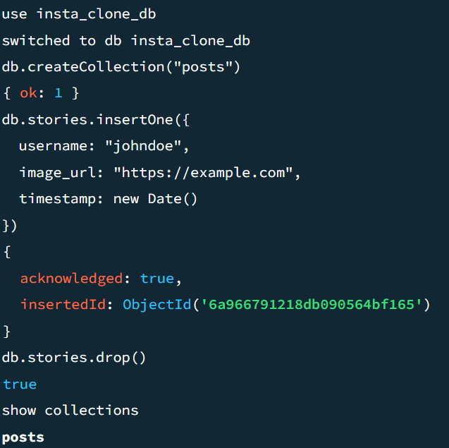
- show dbs

SESSION:-3
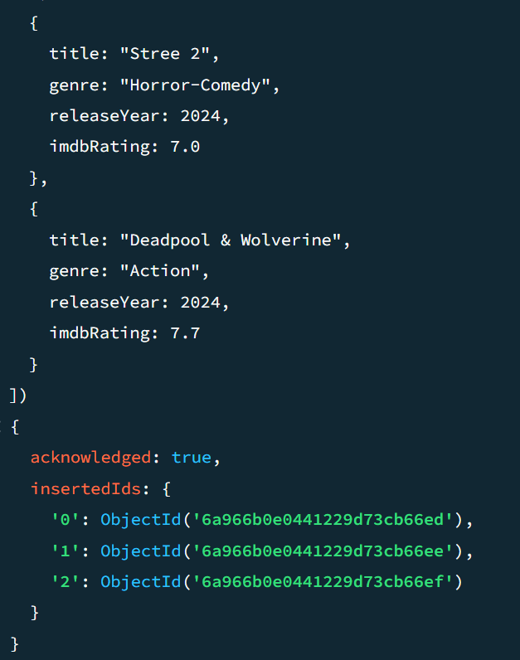
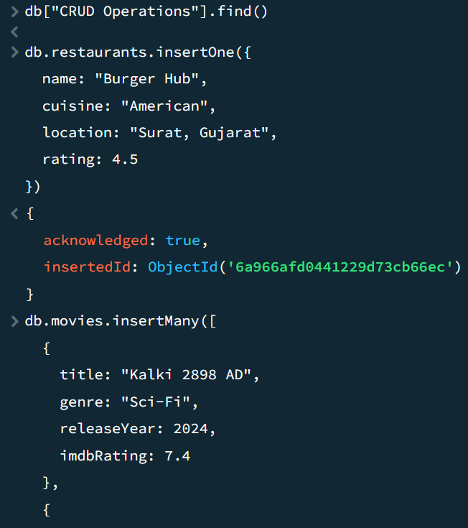

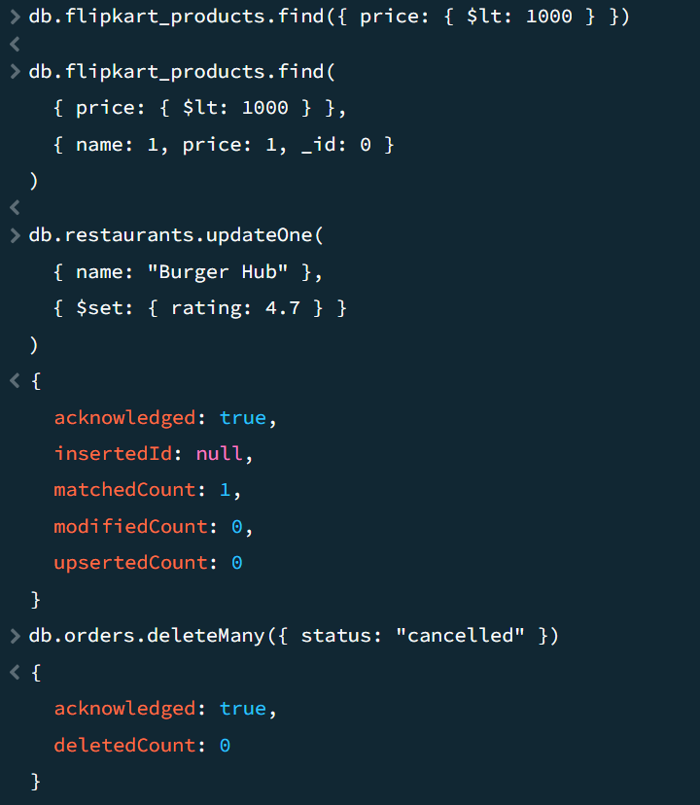

1. Insert one restaurant document
2. Insert three movie documents
3. Find products under ₹1000
4. Update Burger Hub's rating
5. Delete cancelled orders
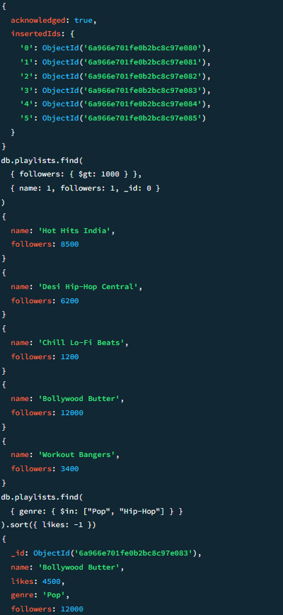
SESSION:-4
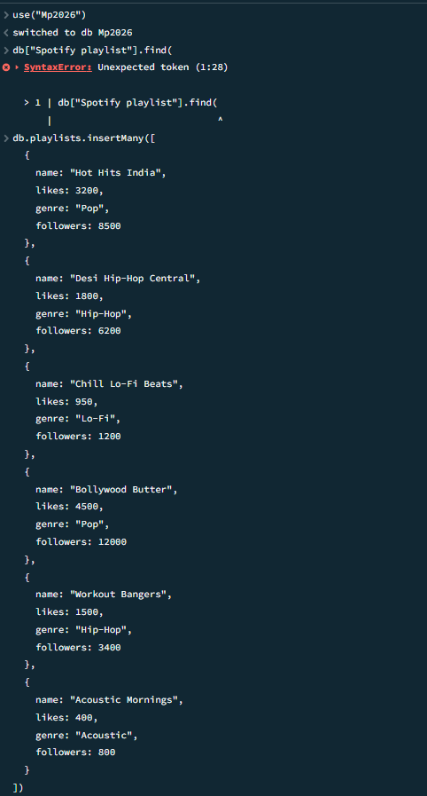
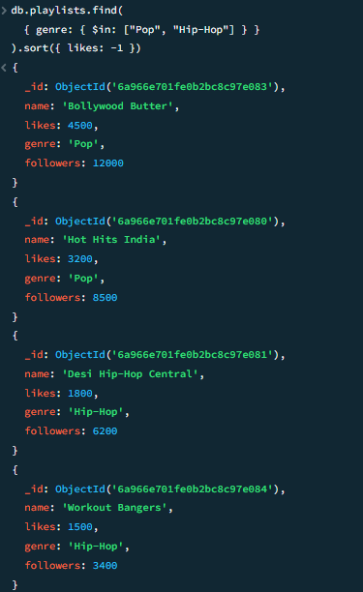
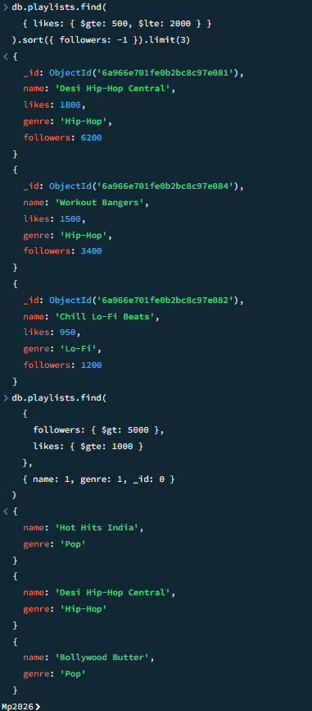

- Insert 5+ playlist documents
- Playlists with more than 1000 followers (projected)
- Pop or Hip-Hop playlists, sorted by likes descending
- Likes between 500–2000, top 3 by followers
- Trending playlists (followers > 5000 AND likes ≥ 1000)

SESSION:-5
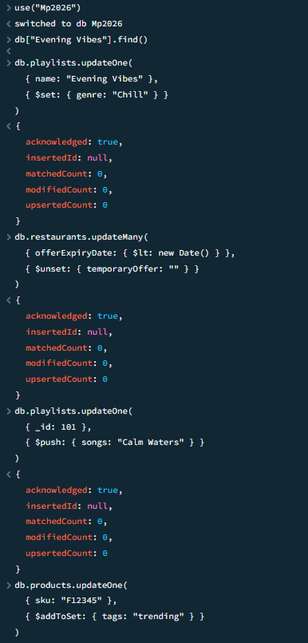
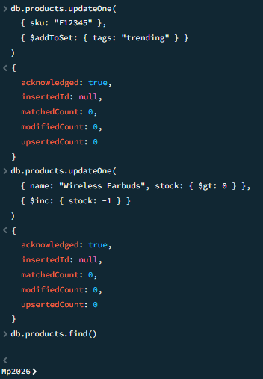

- $set — update genre for 'Evening Vibes'
- $unset — remove expired 'temporaryOffer' field
- $push — add a song to an existing array
- $addToSet — add 'trending' tag without duplicates
- $inc — decrease stock, never below zero

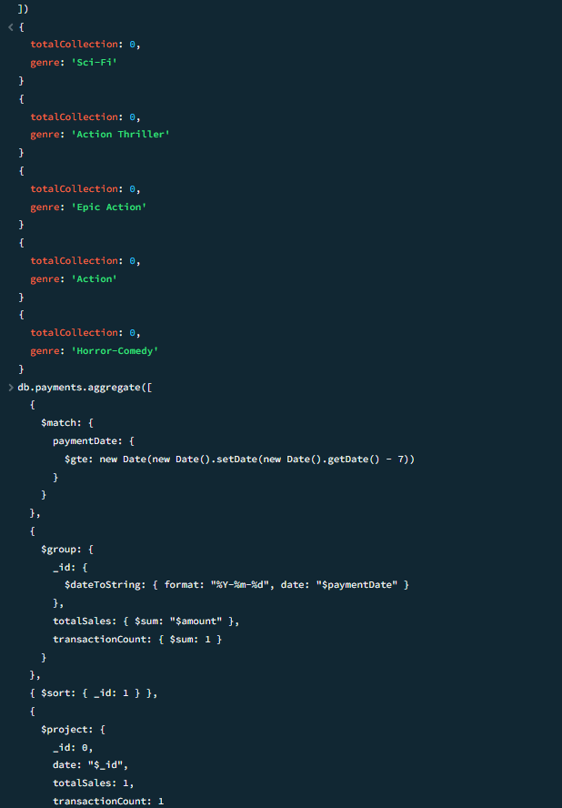
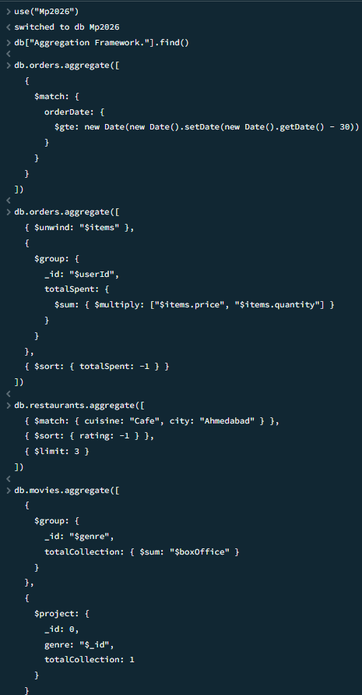
SESSION:-6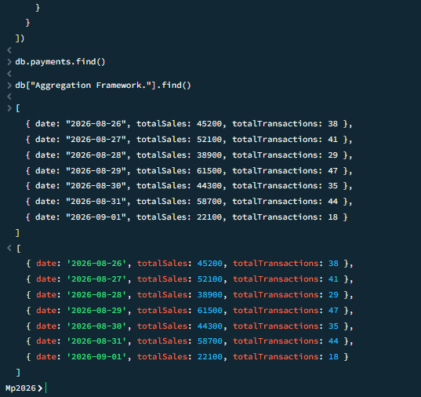
- $match — orders placed in the last 30 days
- $group — total amount spent per user
- Top 3 highest-rated cafes in Ahmedabad
- Total box office collection per genre
- Daily sales report — last 7 days

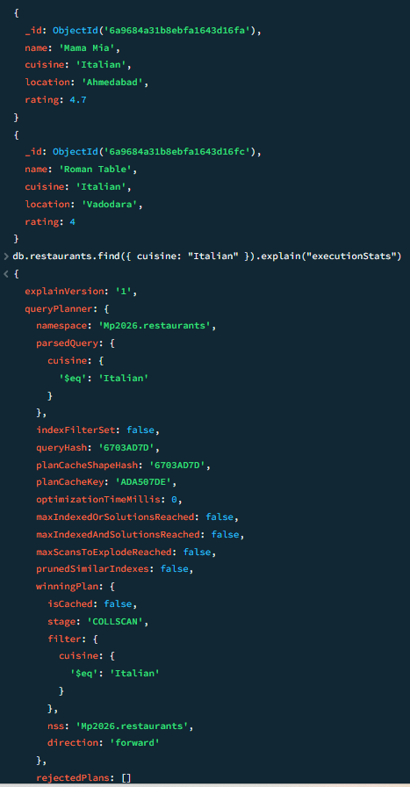
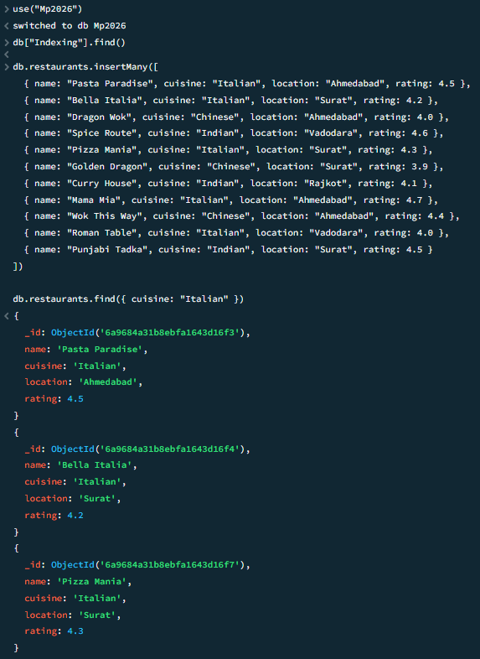
SESSION:-7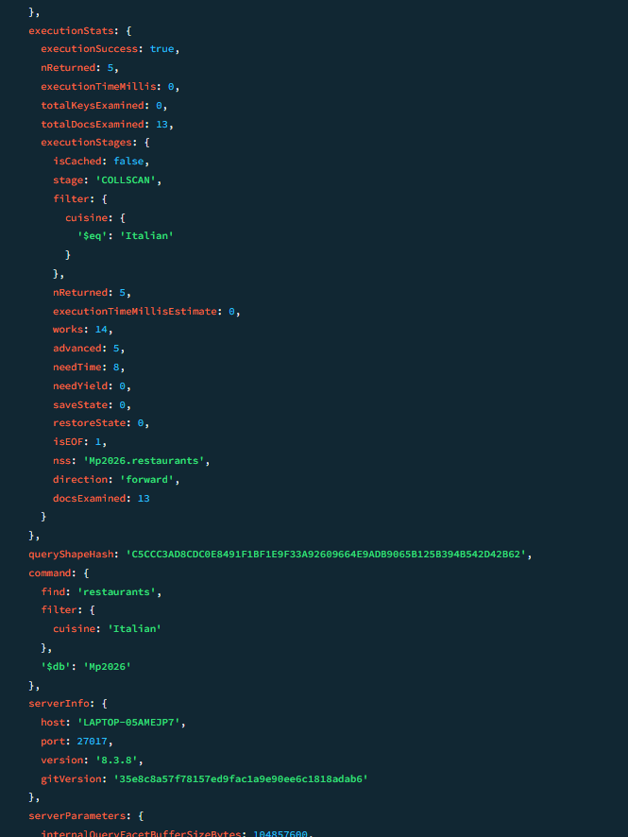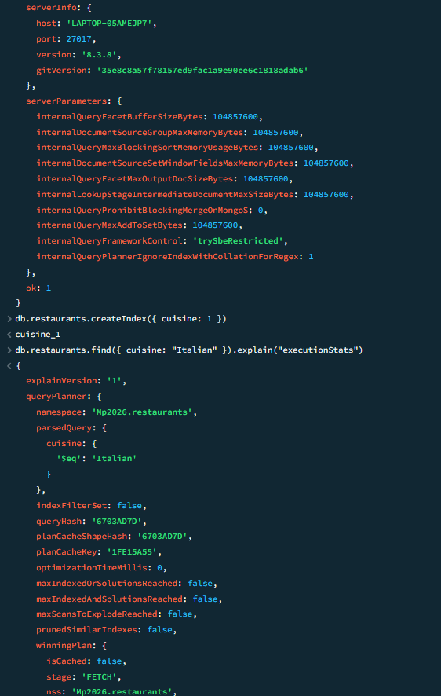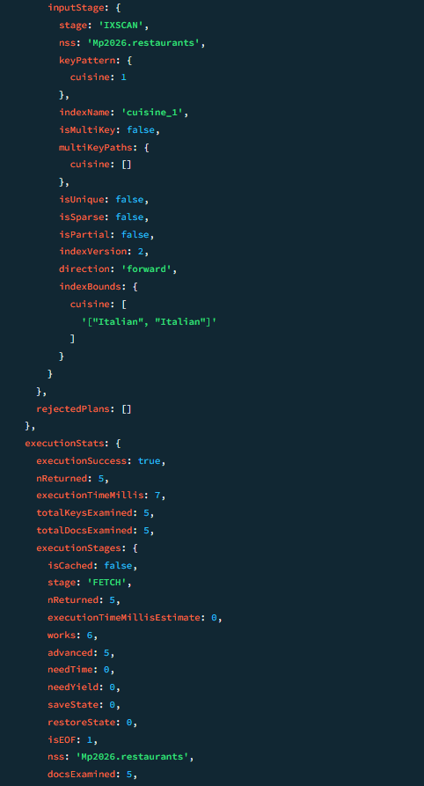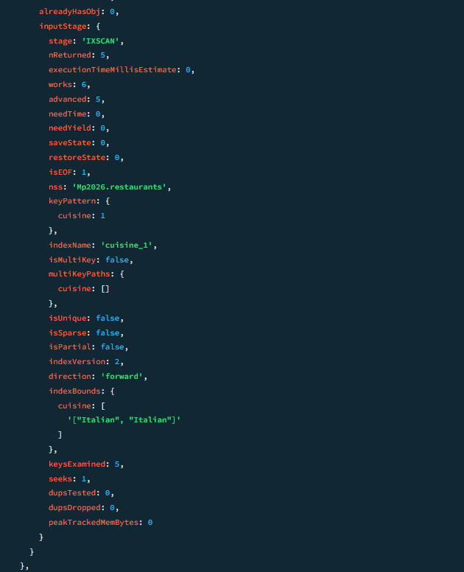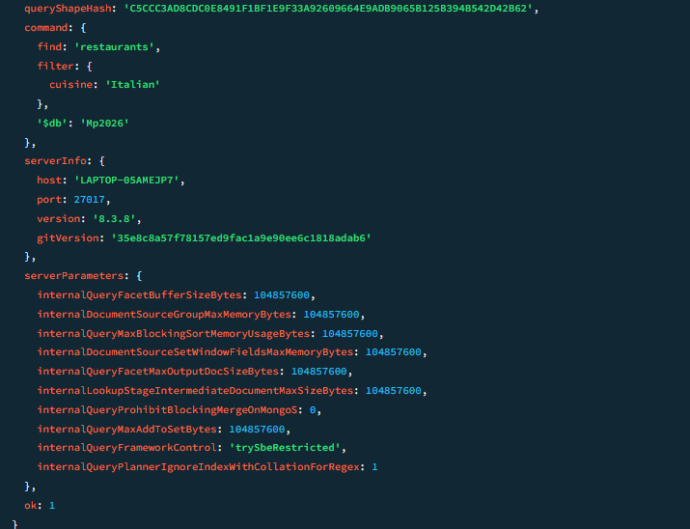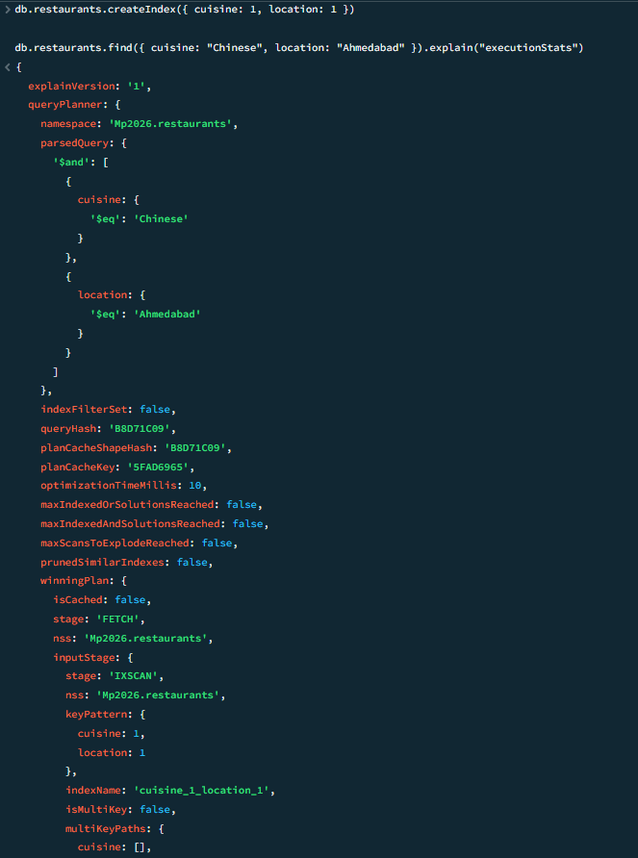

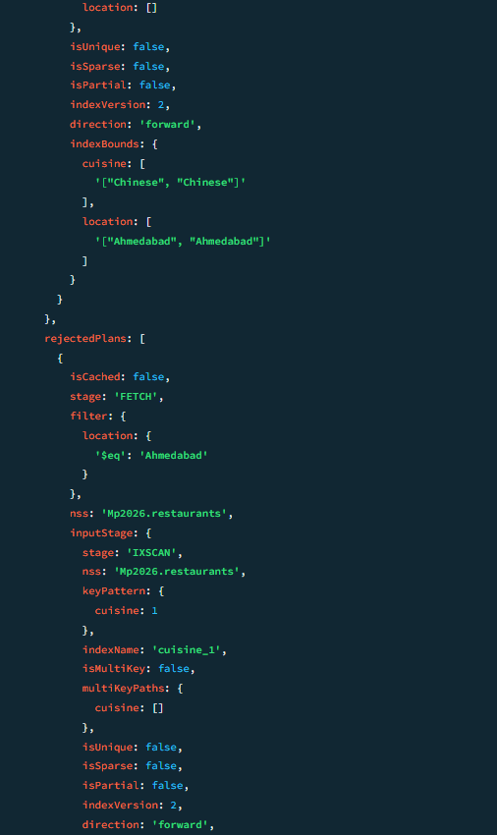
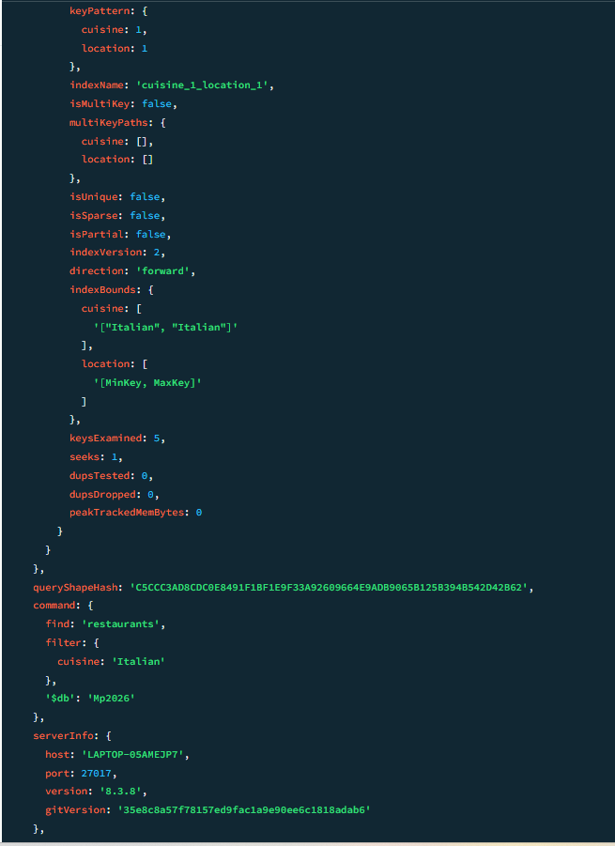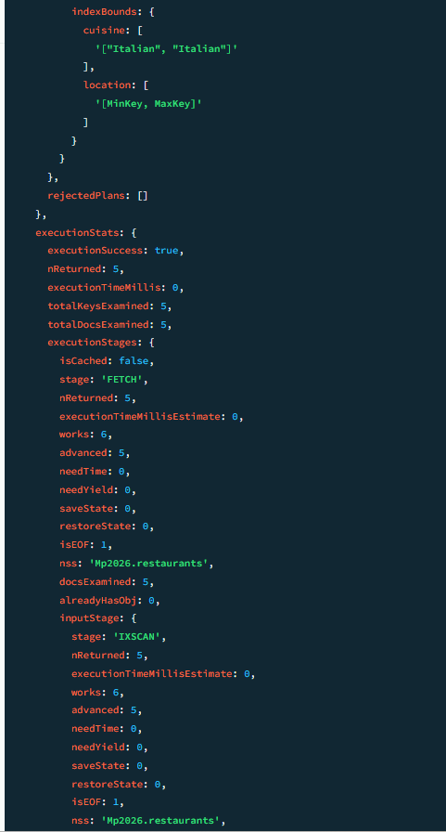

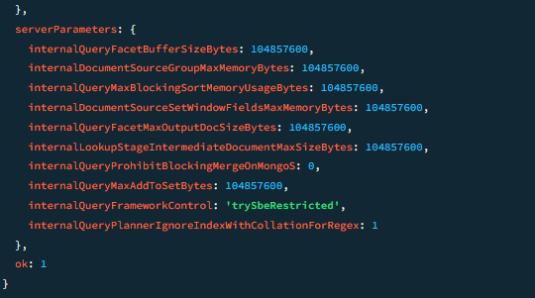
- Insert 10 restaurants and query Italian cuisine
- Add index on 'cuisine' and compare execution time
- Create the index:
- After creating the index:
- Compound index on 'cuisine' and 'location'
- Drop the cuisine index and observe performance

